Compiler Design
Lab Assessment 3

Student Name: Avyakth Shriram
Register Number: 24BCE5461

PROGRAM 1
shift_reduce_parser.c

Aim:
To design, implement, and test a bottom-up Shift-Reduce Parser in C for a given Context-Free Grammar (CFG) to validate whether an input string belongs to the language defined by the grammar.

About:
Shift-Reduce is a bottom-up parsing technique that reads input tokens from left to right, pushing them onto a stack (Shift) until a substring matches a production rule's right-hand side, replacing it with the corresponding non-terminal (Reduce).

Procedure:
- Initialize Data Structures: Create a character array to act as the parser stack (initialized empty with top = -1) and read the input string, appending an end-marker token ($).
- Read & Shift: Read tokens from the input buffer from left to right and push them onto the stack one by one.
- Check for Handle (Reduction): After every shift, inspect the top elements of the stack to see if they match the right-hand side (RHS) of any production rule ($E→\text{id}$, $E→E+E$, $E→E*E$, $E→\left(E\right)$).
- Reduce: If a match (handle) is found, pop the matching RHS symbols from the stack and push the corresponding left-hand side (LHS) non-terminal symbol ($E$). Repeat this step greedily until no further reductions are possible on the current stack top.
- Evaluate Acceptance/Rejection:
  - Accept: If the stack contains only the start symbol $E$ and the input pointer reaches the end-marker $, print the parsing steps and report success.
  - Reject: If no further shifts or reductions are possible and the stack does not reduce to $E$ at $, or an invalid token sequence occurs, terminate and flag a syntax error.

C Program Code:

#include <stdio.h>
#include <string.h>
#include <stdlib.h>

char stack[100];
int top = -1;
char input[100];
int ip = 0;

void push(char c) {
stack[++top] = c;
stack[top + 1] = '\0';
}

void pop() {
if (top >= 0) {
stack[top] = '\0';
top--;
}
}

void print_step(const char *action) {
printf("%-20s %-20s %-25s\n", stack, &input[ip], action);
}

// Checks stack top for reducible patterns: id, E+E, E*E, (E)
int reduce() {
// Check for "id"
if (top >= 1 && stack[top - 1] == 'i' && stack[top] == 'd') {
pop(); // remove 'd'
pop(); // remove 'i'
push('E');
print_step("Reduce: E -> id");
return 1;
}
// Check for "E+E"
if (top >= 2 && stack[top - 2] == 'E' && stack[top - 1] == '+' && stack[top] == 'E') {
pop(); // remove 'E'
pop(); // remove '+'
pop(); // remove 'E'
push('E');
print_step("Reduce: E -> E+E");
return 1;
}
// Check for "E*E"
if (top >= 2 && stack[top - 2] == 'E' && stack[top - 1] == '*' && stack[top] == 'E') {
pop(); // remove 'E'
pop(); // remove '*'
pop(); // remove 'E'
push('E');
print_step("Reduce: E -> E*E");
return 1;
}
// Check for "(E)"
if (top >= 2 && stack[top - 2] == '(' && stack[top - 1] == 'E' && stack[top] == ')') {
pop(); // remove ')'
pop(); // remove 'E'
pop(); // remove '('
push('E');
print_step("Reduce: E -> (E)");
return 1;
}
return 0;
}

int main() {
char raw_input[100];
printf("=====================================================\n");
printf(" EXPERIMENT 5: SHIFT-REDUCE PARSER \n");
printf(" Grammar: \n");
printf(" 1. E -> E + E \n");
printf(" 2. E -> E * E \n");
printf(" 3. E -> (E) \n");
printf(" 4. E -> id \n");
printf("=====================================================\n");
printf("Enter input string (e.g., id+id*id, (id+id), id*id): ");
if (scanf("%99s", raw_input) != 1) return 0;

// Append end-marker '$'
snprintf(input, sizeof(input), "%s$", raw_input);

stack[0] = '\0';
top = -1;
ip = 0;

printf("\n%-20s %-20s %-25s\n", "STACK", "INPUT BUFFER", "ACTION");
printf("-----------------------------------------------------------------\n");

while (1) {
// Shift step if not at end of input
if (input[ip] != '$') {
if (input[ip] == 'i' && input[ip + 1] == 'd') {
push(input[ip++]);
push(input[ip++]);
print_step("Shift (id)");
} else {
char ch = input[ip++];
push(ch);
char action[30];
snprintf(action, sizeof(action), "Shift (%c)", ch);
print_step(action);
}
}

// Apply reductions greedily
while (reduce());

// Acceptance condition: Stack has only 'E' and input is at '$'
if (top == 0 && stack[0] == 'E' && input[ip] == '$') {
printf("%-20s %-20s %-25s\n", stack, "$", "ACCEPT");
printf("\n>> SUCCESS: The string \"%s\" is VALID and ACCEPTED.\n", raw_input);
break;
}

// Error / Rejection condition
if (input[ip] == '$' && !(top == 0 && stack[0] == 'E')) {
printf("\n>> ERROR: The string \"%s\" is INVALID and REJECTED.\n", raw_input);
break;
}
}

return 0;
}

Screenshots & Output:

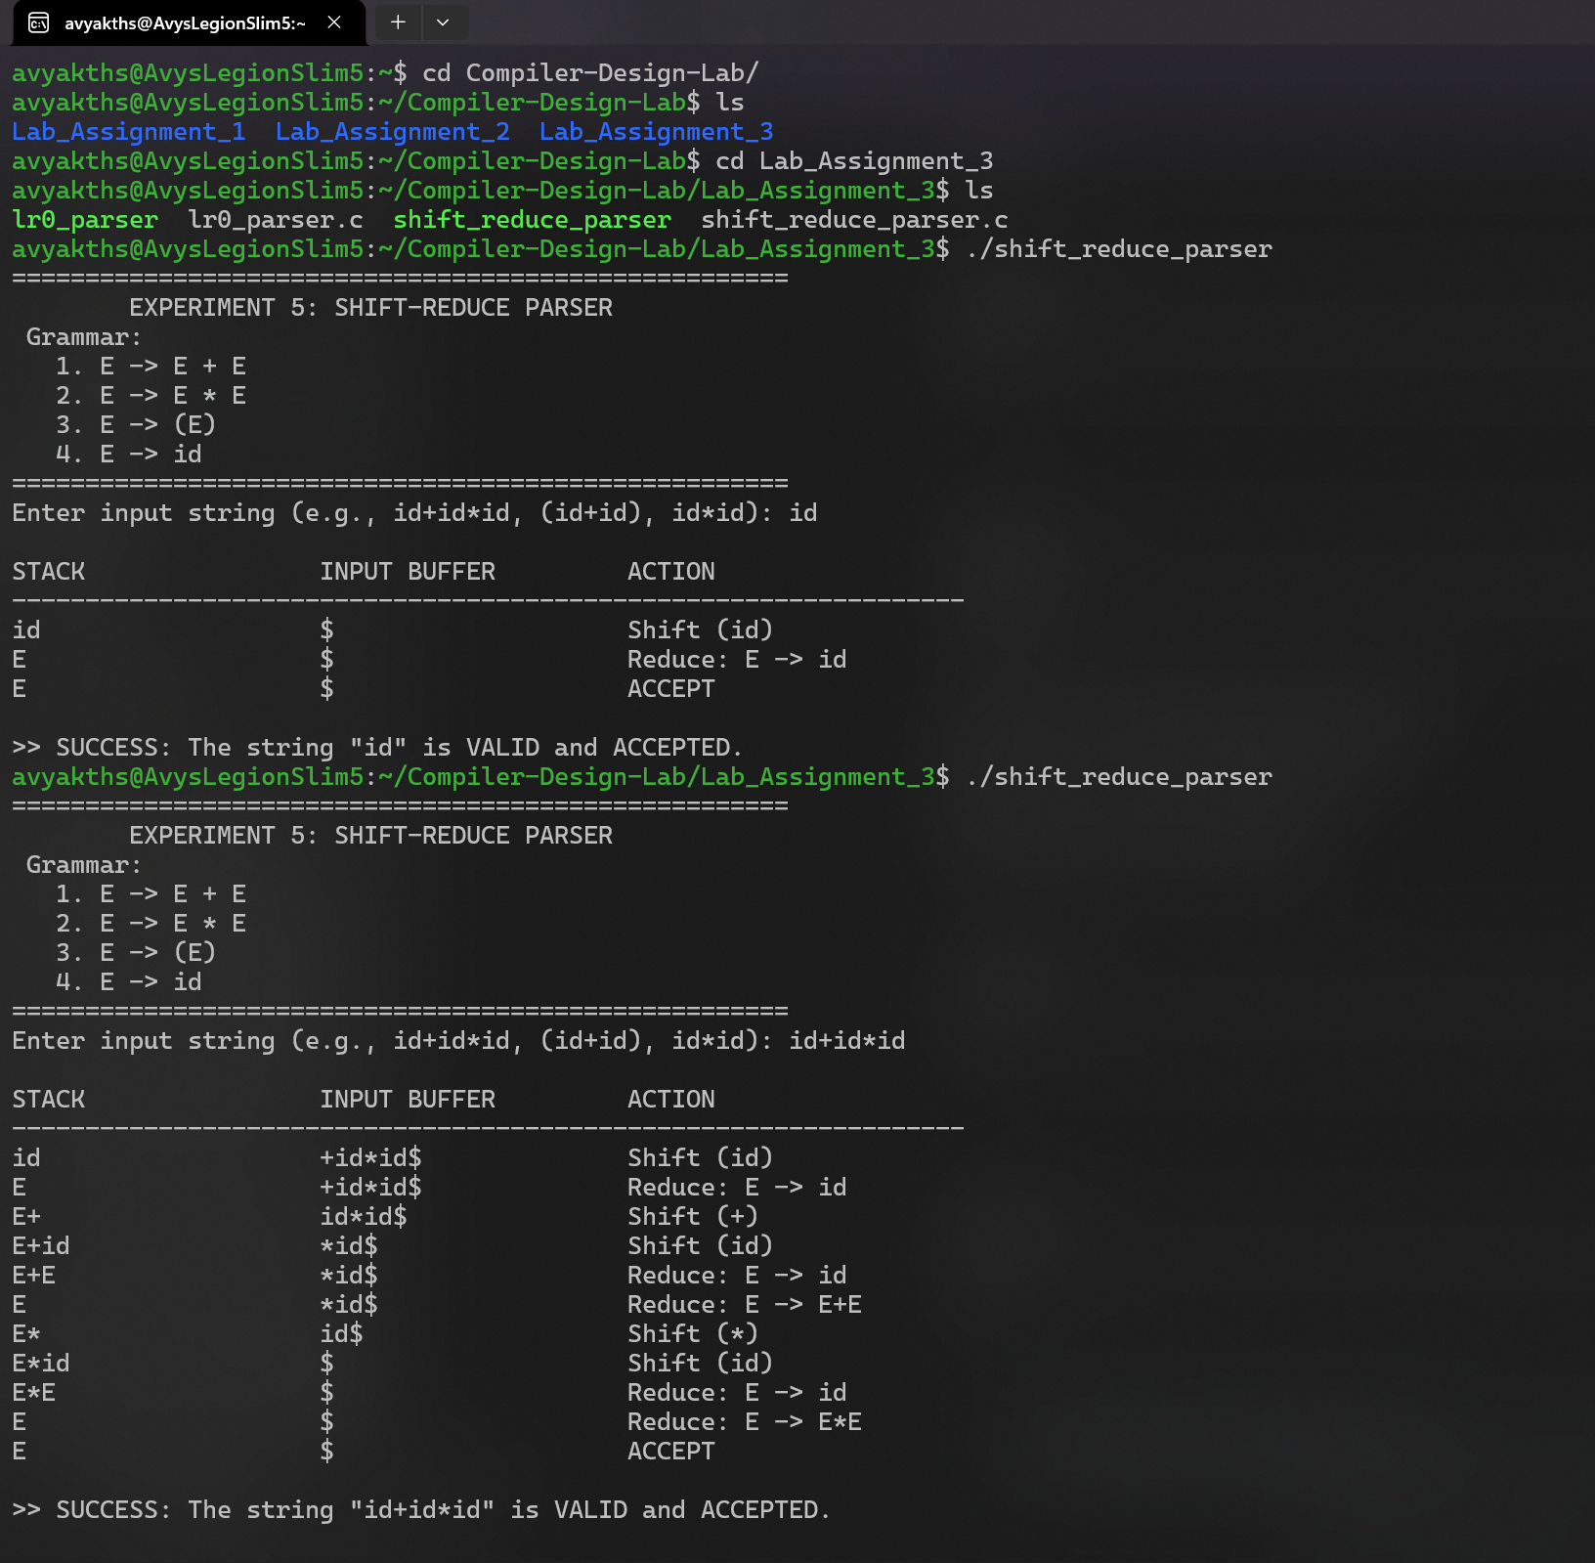
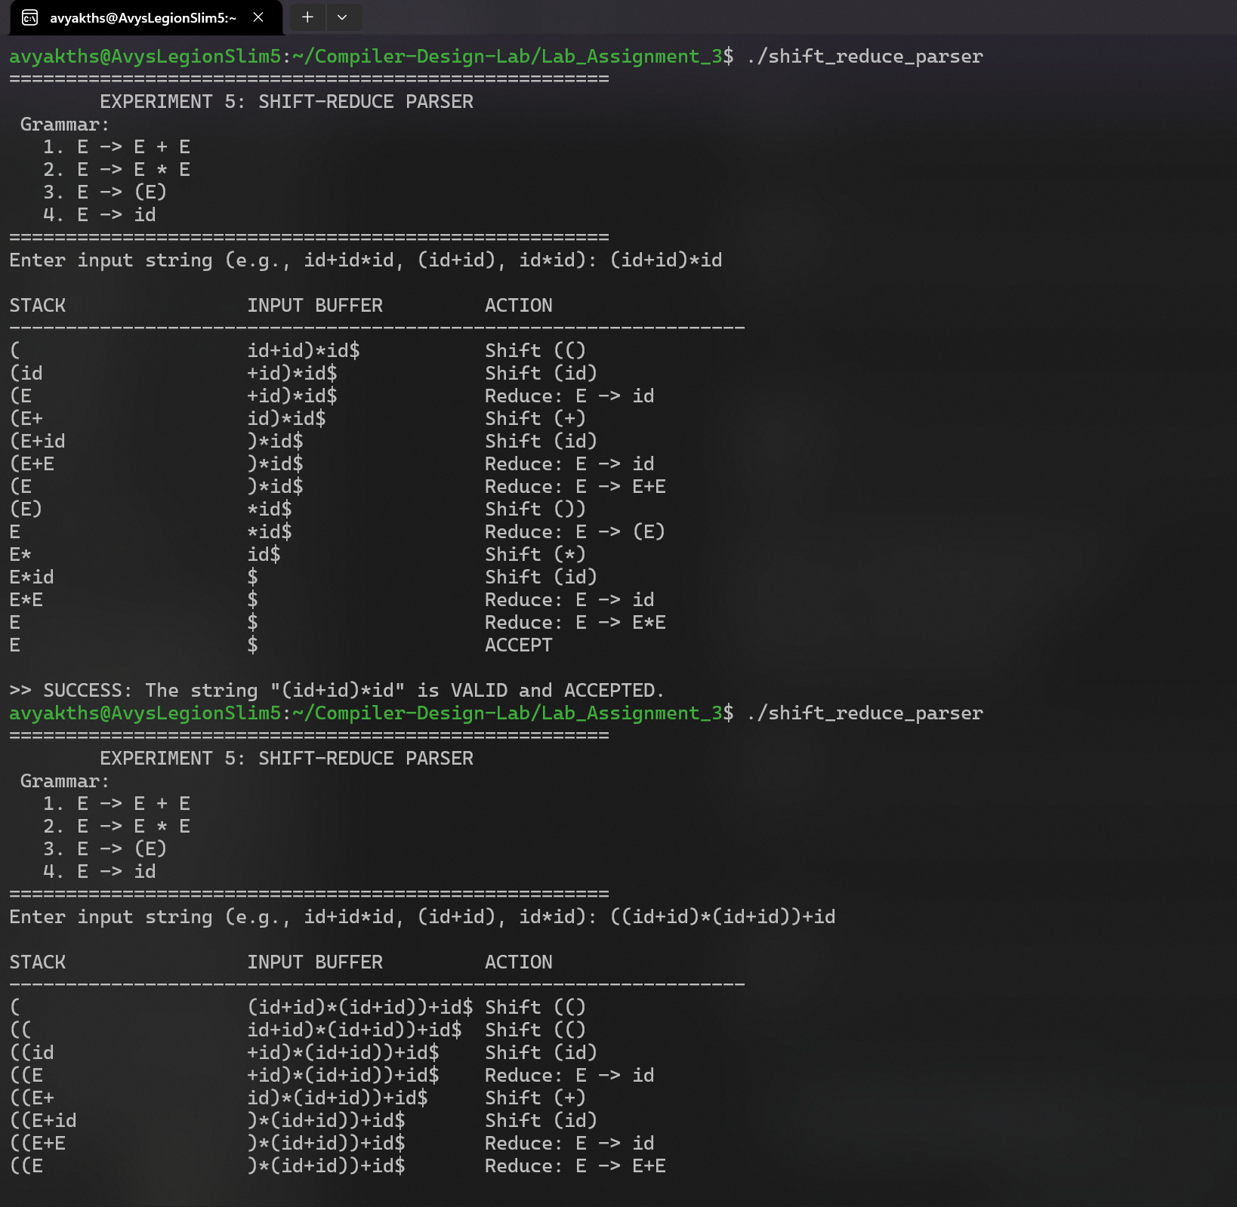
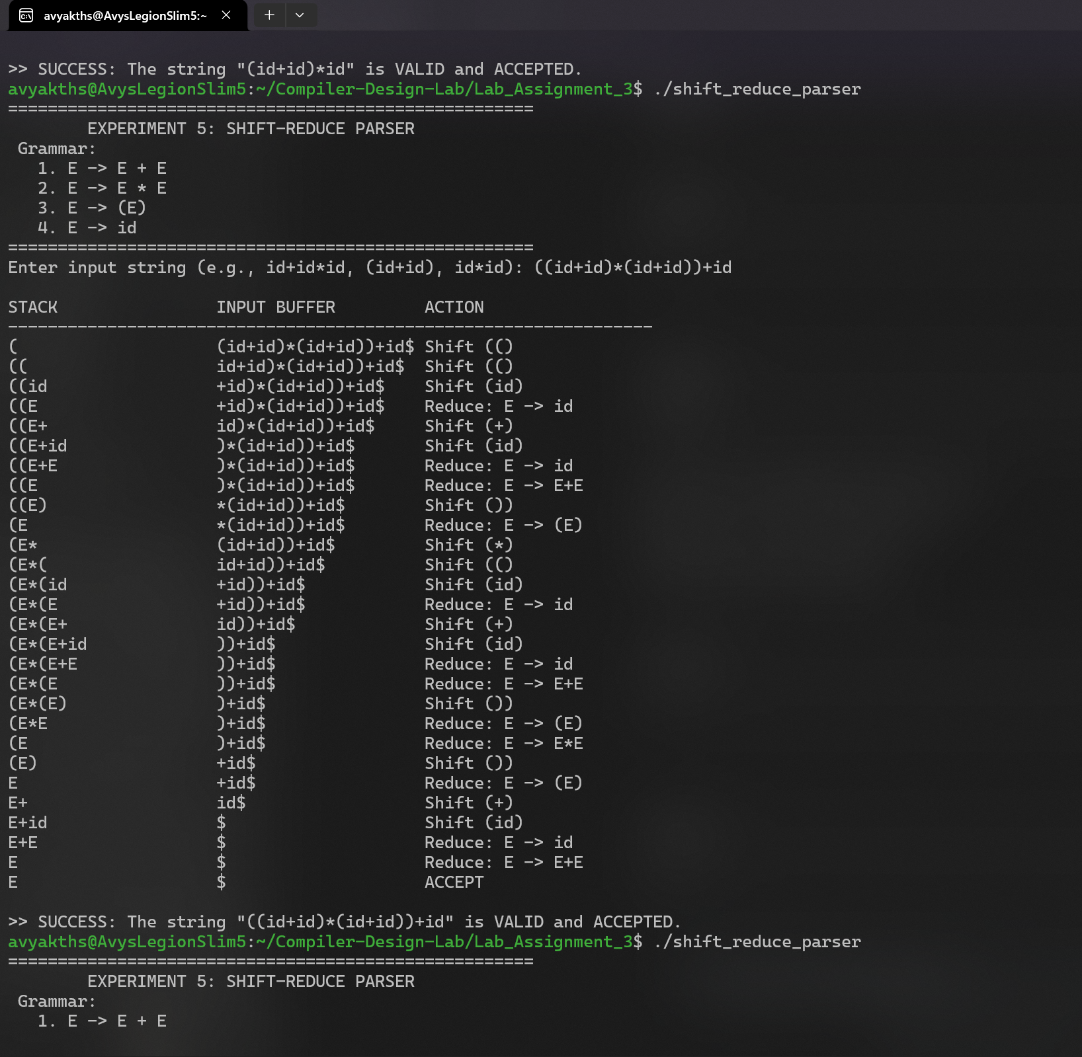
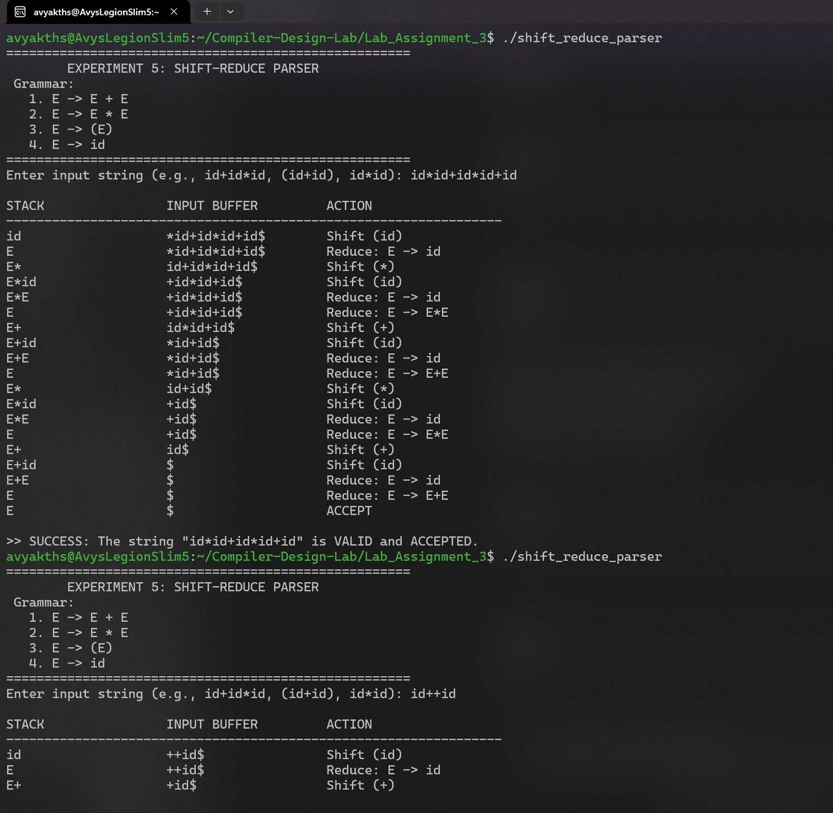
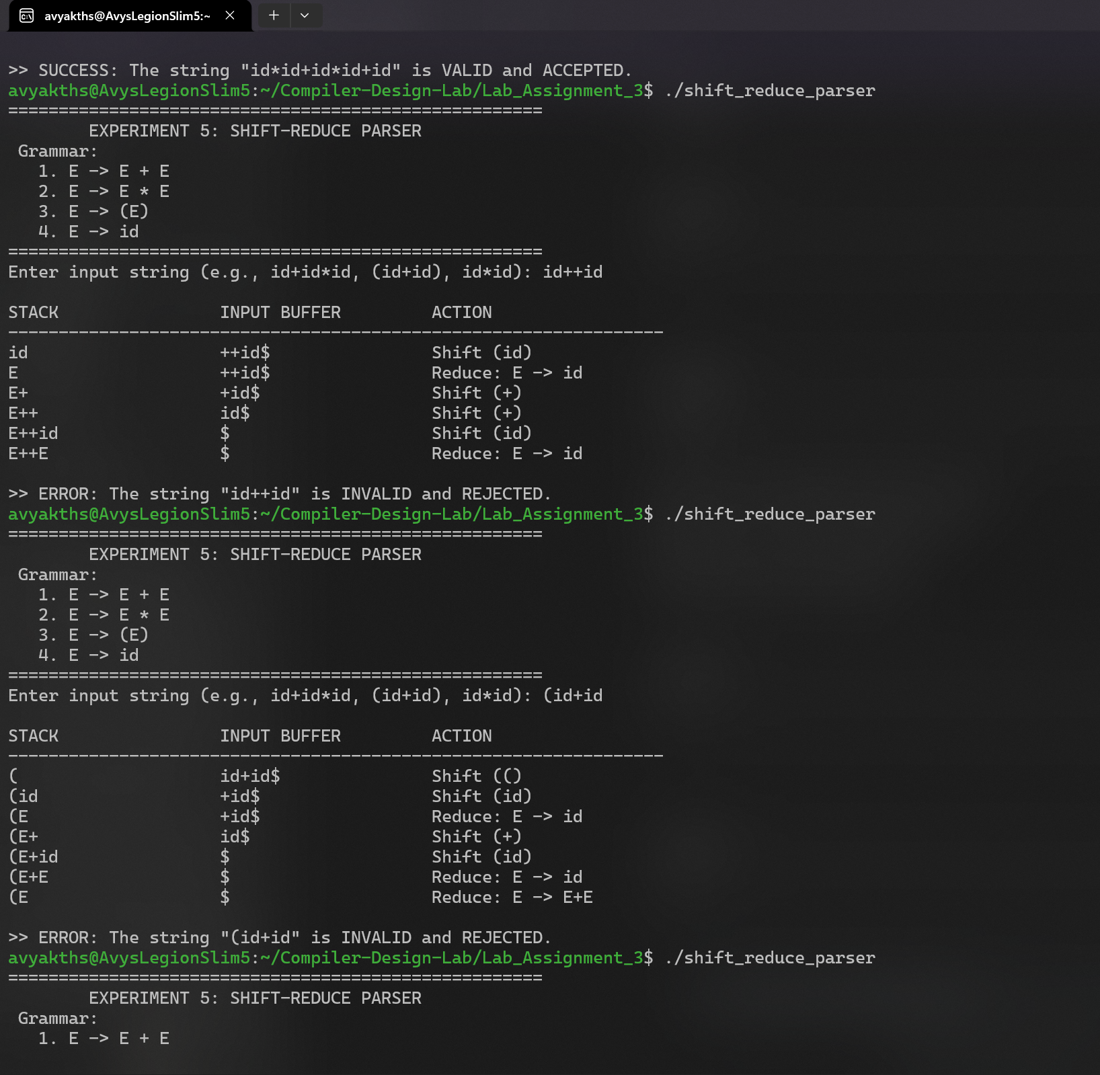
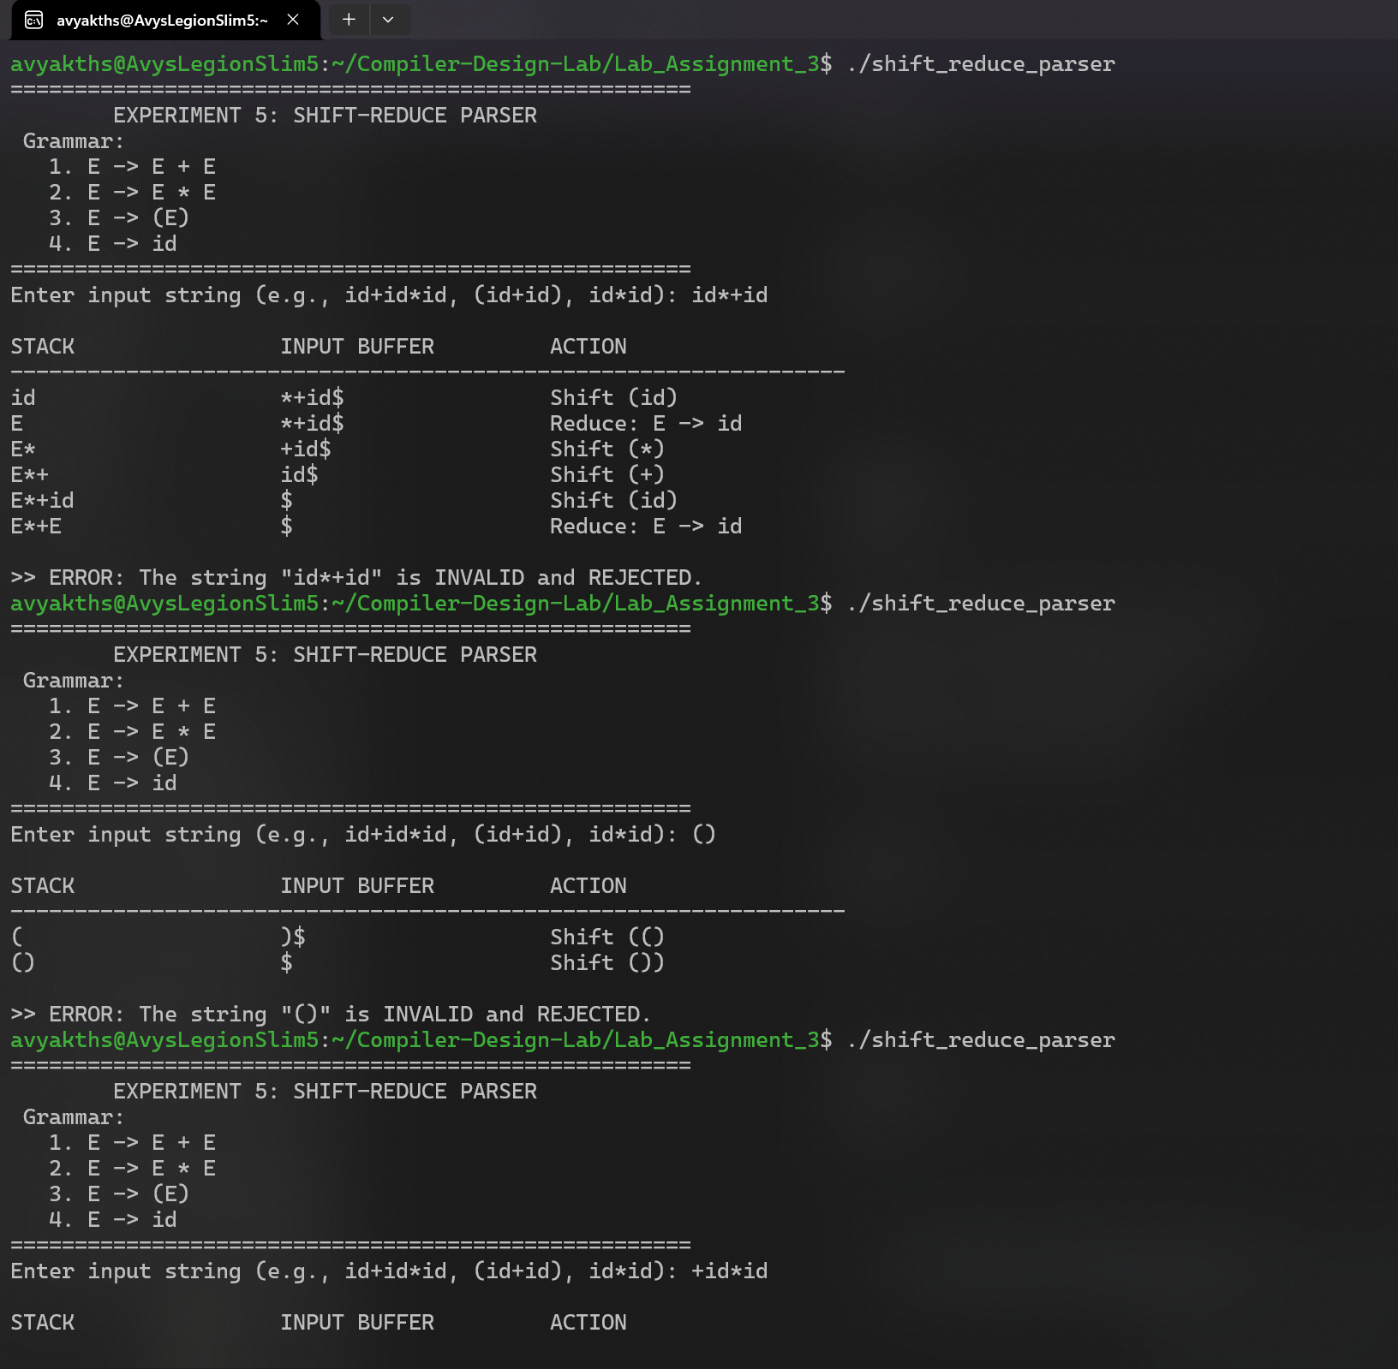
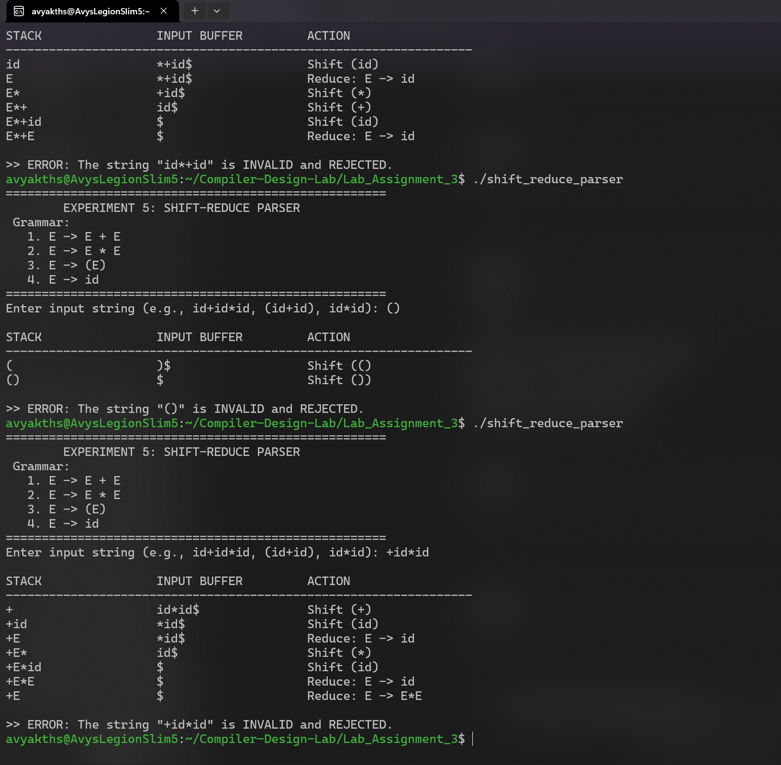

PROGRAM 2
lr0_parser.c

Aim:
To implement an LR(0) Parser in C by generating the canonical collection of LR(0) items, constructing the LR(0) Action and Goto parsing tables for a conflict-free grammar, and validating input strings through deterministic stack-based parsing.

About:
An LR(0) parser builds the canonical collection of LR(0) items using Closure and Goto operations. In an LR(0) table, a state with a completed production item ($A→α⋅$) receives reduce actions across all terminals in that row.

Procedure:
- Augment the Grammar: Given the grammar $G$, construct the augmented grammar $G'$ by introducing a new start symbol and production $S'→S$.
- Compute Canonical Collection of LR(0) Items:
  - Define an item structure containing the LHS, RHS, and a dot position (dot).
  - Implement the CLOSURE(I) function: If item $\left[A→α⋅Bβ\right]$ is in $I$, add $\left[B→⋅γ\right]$ for all productions of $B$ until no new items can be added.
  - Implement the GOTO(I, X) function: Transition the dot over symbol $X$ for all items $\left[A→α⋅Xβ\right]$ in $I$ and compute the closure of the resulting set.
  - Generate all unique states (sets of items) starting from $I_{0}=\text{CLOSURE}\left(\left\{\left[S'→⋅S\right]\right\}\right)$.
- Construct the LR(0) Parsing Table:
  - Shift Actions: If $\left[A→α⋅aβ\right]∈I_{i}$ and $\text{GOTO}\left(I_{i},a\right)=I_{j}$, set $\text{ACTION}\left[i,a\right]=\text{shift }j$.
  - Goto Actions: If $\text{GOTO}\left(I_{i},A\right)=I_{j}$ for a non-terminal $A$, set $\text{GOTO}\left[i,A\right]=j$.
  - Reduce Actions: If $\left[A→α⋅\right]∈I_{i}$, set $\text{ACTION}\left[i,a\right]=\text{reduce }\left(A→α\right)$ for all terminals $a∈T∪\left\{\$\right\}$.
  - Accept Action: If $\left[S'→S⋅\right]∈I_{i}$, set $\text{ACTION}\left[i,\$\right]=\text{accept}$.
- Parse the Input String:
  - Initialize a state stack with state $0$ and a symbol stack with $.
  - Look up the current state $s$ (stack top) and the current input symbol $a$ in $\text{ACTION}\left[s,a\right]$.
  - If $\text{shift }j$: Push symbol $a$ and state $j$ onto their respective stacks, then advance the input pointer.
  - If $\text{reduce }\left(A→α\right)$: Pop $|α|$ symbols and states from the stacks. Look up state $s'$ now on top of the stack and determine $j=\text{GOTO}\left[s',A\right]$. Push non-terminal $A$ and state $j$.
  - If $\text{accept}$: Output the trace table and conclude that the string is syntactically valid.
  - If blank/error: Terminate and declare a syntax error.

C Program Code:

#include <stdio.h>
#include <string.h>
#include <stdlib.h>

#define MAX_ITEMS 30
#define MAX_STATES 30
#define MAX_PROD 10

typedef struct {
char lhs;
char rhs[10];
int dot;
} Item;

typedef struct {
Item items[MAX_ITEMS];
int count;
} State;

typedef struct {
char lhs;
char rhs[10];
} Production;

// Strictly LR(0) Prefix Expression Grammar
Production prods[MAX_PROD] = {
{'E', "+EE"}, // 0
{'E', "*EE"}, // 1
{'E', "(E)"}, // 2
{'E', "i"} // 3
};
int num_prods = 4;

State states[MAX_STATES];
int num_states = 0;

char terminals[] = {'+', '*', '(', ')', 'i', '$'};
int num_terminals = 6;
char non_terminals[] = {'E'};
int num_non_terminals = 1;

char action_type[MAX_STATES][10];
int action_val[MAX_STATES][10];
int goto_table[MAX_STATES][10];

int item_exists(State *s, Item it) {
for (int i = 0; i < s->count; i++) {
if (s->items[i].lhs == it.lhs &&
strcmp(s->items[i].rhs, it.rhs) == 0 &&
s->items[i].dot == it.dot)
return 1;
}
return 0;
}

void add_item(State *s, Item it) {
if (!item_exists(s, it)) {
s->items[s->count++] = it;
}
}

void closure(State *s) {
int added = 1;
while (added) {
added = 0;
int current_count = s->count;
for (int i = 0; i < current_count; i++) {
Item it = s->items[i];
if (it.dot < (int)strlen(it.rhs)) {
char symbol = it.rhs[it.dot];
for (int j = 0; j < num_prods; j++) {
if (prods[j].lhs == symbol) {
Item new_it = {prods[j].lhs, "", 0};
strcpy(new_it.rhs, prods[j].rhs);
if (!item_exists(s, new_it)) {
add_item(s, new_it);
added = 1;
}
}
}
}
}
}
}

State find_goto(State *s, char symbol) {
State res;
res.count = 0;
for (int i = 0; i < s->count; i++) {
Item it = s->items[i];
if (it.dot < (int)strlen(it.rhs) && it.rhs[it.dot] == symbol) {
Item next_it = it;
next_it.dot++;
add_item(&res, next_it);
}
}
if (res.count > 0) closure(&res);
return res;
}

int find_state_index(State *s) {
for (int i = 0; i < num_states; i++) {
if (states[i].count == s->count) {
int match = 1;
for (int j = 0; j < s->count; j++) {
if (!item_exists(&states[i], s->items[j])) {
match = 0;
break;
}
}
if (match) return i;
}
}
return -1;
}

int get_term_idx(char c) {
for (int i = 0; i < num_terminals; i++)
if (terminals[i] == c) return i;
return -1;
}

int get_nterm_idx(char c) {
for (int i = 0; i < num_non_terminals; i++)
if (non_terminals[i] == c) return i;
return -1;
}

void build_table() {
State s0;
s0.count = 0;
Item init_item = {'Z', "E", 0}; // Z = E' (Augmented)
add_item(&s0, init_item);
closure(&s0);
states[num_states++] = s0;

for (int i = 0; i < num_states; i++) {
// Shift transitions
for (int t = 0; t < num_terminals - 1; t++) {
char sym = terminals[t];
State next_s = find_goto(&states[i], sym);
if (next_s.count > 0) {
int idx = find_state_index(&next_s);
if (idx == -1) {
idx = num_states;
states[num_states++] = next_s;
}
action_type[i][t] = 's';
action_val[i][t] = idx;
}
}

// Goto transitions
for (int nt = 0; nt < num_non_terminals; nt++) {
char sym = non_terminals[nt];
State next_s = find_goto(&states[i], sym);
if (next_s.count > 0) {
int idx = find_state_index(&next_s);
if (idx == -1) {
idx = num_states;
states[num_states++] = next_s;
}
goto_table[i][nt] = idx;
} else {
goto_table[i][nt] = -1;
}
}

// LR(0) Reduce and Accept transitions
for (int j = 0; j < states[i].count; j++) {
Item it = states[i].items[j];
if (it.lhs == 'Z' && it.dot == (int)strlen(it.rhs)) {
int dollar_idx = get_term_idx('$');
action_type[i][dollar_idx] = 'a';
} else if (it.dot == (int)strlen(it.rhs)) {
int p_idx = -1;
for (int k = 0; k < num_prods; k++) {
if (prods[k].lhs == it.lhs && strcmp(prods[k].rhs, it.rhs) == 0) {
p_idx = k;
break;
}
}
// LR(0): Place reduce across every terminal
for (int t = 0; t < num_terminals; t++) {
action_type[i][t] = 'r';
action_val[i][t] = p_idx;
}
}
}
}
}

void print_table() {
printf("\n=============================== LR(0) PARSING TABLE ===============================\n");
printf("%-7s | %-35s | %-10s\n", "STATE", "ACTION", "GOTO");
printf(" |");
for (int i = 0; i < num_terminals; i++) printf(" %-5c", terminals[i]);
printf(" |");
for (int i = 0; i < num_non_terminals; i++) printf(" %-5c", non_terminals[i]);
printf("\n------------------------------------------------------------------------------------\n");

for (int i = 0; i < num_states; i++) {
printf("I%-6d |", i);
for (int t = 0; t < num_terminals; t++) {
if (action_type[i][t] == 's') {
char buf[10];
snprintf(buf, sizeof(buf), "s%d", action_val[i][t]);
printf(" %-5s", buf);
} else if (action_type[i][t] == 'r') {
char buf[10];
snprintf(buf, sizeof(buf), "r%d", action_val[i][t]);
printf(" %-5s", buf);
} else if (action_type[i][t] == 'a') {
printf(" %-5s", "acc");
} else {
printf(" %-5s", ".");
}
}
printf(" |");
for (int nt = 0; nt < num_non_terminals; nt++) {
if (goto_table[i][nt] != -1) {
printf(" %-5d", goto_table[i][nt]);
} else {
printf(" %-5s", ".");
}
}
printf("\n");
}
printf("====================================================================================\n");
}

void parse_string(const char *raw_str) {
char input[100];
snprintf(input, sizeof(input), "%s$", raw_str);

int state_stack[100];
char sym_stack[100];
int top = 0;

state_stack[0] = 0;
sym_stack[0] = '$';
sym_stack[1] = '\0';

int ip = 0;

printf("\n%-25s %-15s %-20s %-20s\n", "STATE STACK", "SYMBOL STACK", "INPUT", "ACTION");
printf("------------------------------------------------------------------------------------\n");

while (1) {
int s = state_stack[top];
char a = input[ip];
int t_idx = get_term_idx(a);

if (t_idx == -1) {
printf("\n>> ERROR: Invalid token '%c' in input stream.\n", a);
return;
}

char state_str[50] = "";
for (int i = 0; i <= top; i++) {
char buf[10];
snprintf(buf, sizeof(buf), "%d ", state_stack[i]);
strcat(state_str, buf);
}

char action_str[50] = "";
char act = action_type[s][t_idx];
int val = action_val[s][t_idx];

if (act == 's') {
snprintf(action_str, sizeof(action_str), "Shift -> I%d", val);
printf("%-25s %-15s %-20s %-20s\n", state_str, sym_stack, &input[ip], action_str);
top++;
state_stack[top] = val;
sym_stack[top] = a;
sym_stack[top + 1] = '\0';
ip++;
} else if (act == 'r') {
snprintf(action_str, sizeof(action_str), "Reduce: %c -> %s", prods[val].lhs, prods[val].rhs);
printf("%-25s %-15s %-20s %-20s\n", state_str, sym_stack, &input[ip], action_str);
int len = strlen(prods[val].rhs);
top -= len;
int prev_state = state_stack[top];
char lhs = prods[val].lhs;
int nt_idx = get_nterm_idx(lhs);
int next_state = goto_table[prev_state][nt_idx];

top++;
state_stack[top] = next_state;
sym_stack[top] = lhs;
sym_stack[top + 1] = '\0';
} else if (act == 'a') {
printf("%-25s %-15s %-20s %-20s\n", state_str, sym_stack, &input[ip], "Accept");
printf("\n>> SUCCESS: String \"%s\" successfully parsed and accepted!\n", raw_str);
return;
} else {
printf("%-25s %-15s %-20s %-20s\n", state_str, sym_stack, &input[ip], "Error");
printf("\n>> ERROR: Parsing failed. Syntax error at '%c'.\n", a);
return;
}
}
}

int main() {
printf("=====================================================\n");
printf(" EXPERIMENT 6: LR(0) PREFIX EXPRESSION PARSER \n");
printf(" Grammar: \n");
printf(" 0. E -> + E E \n");
printf(" 1. E -> * E E \n");
printf(" 2. E -> ( E ) \n");
printf(" 3. E -> i \n");
printf("=====================================================\n");

build_table();
print_table();

char test_input[100];
printf("\nEnter prefix expression to parse (e.g., +ii, *+iii, +*(i)ii): ");
if (scanf("%99s", test_input) == 1) {
parse_string(test_input);
}
return 0;
}

Screenshots & Output:

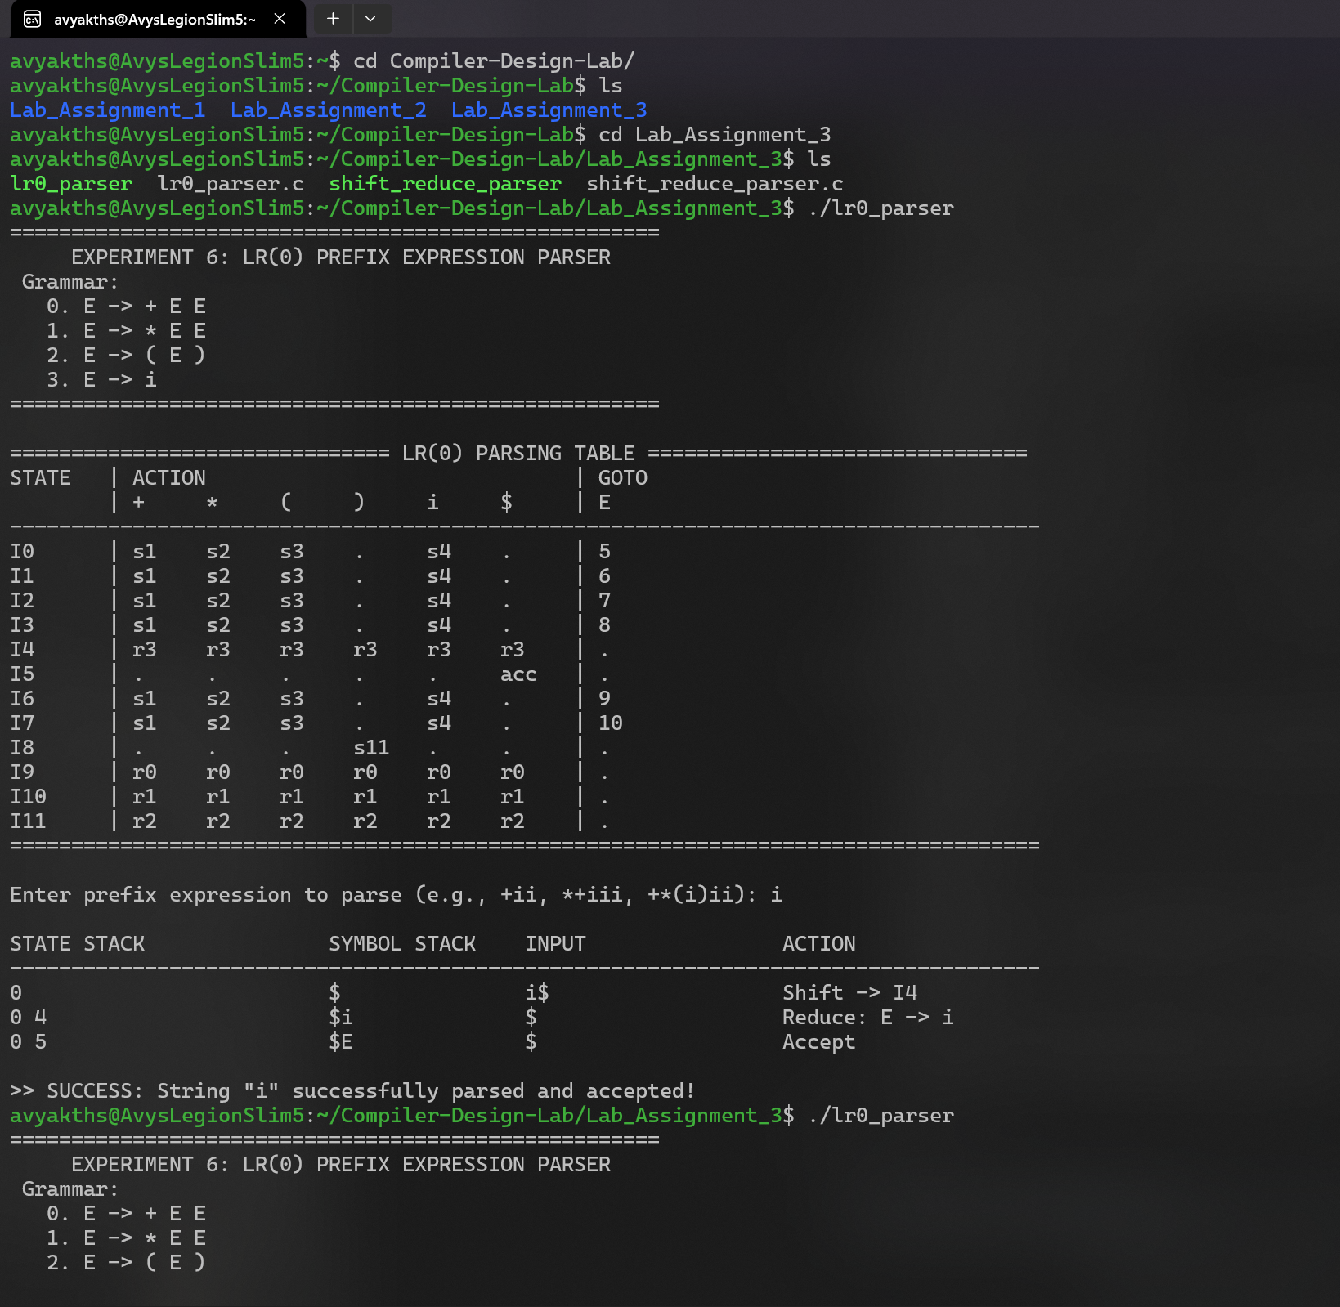
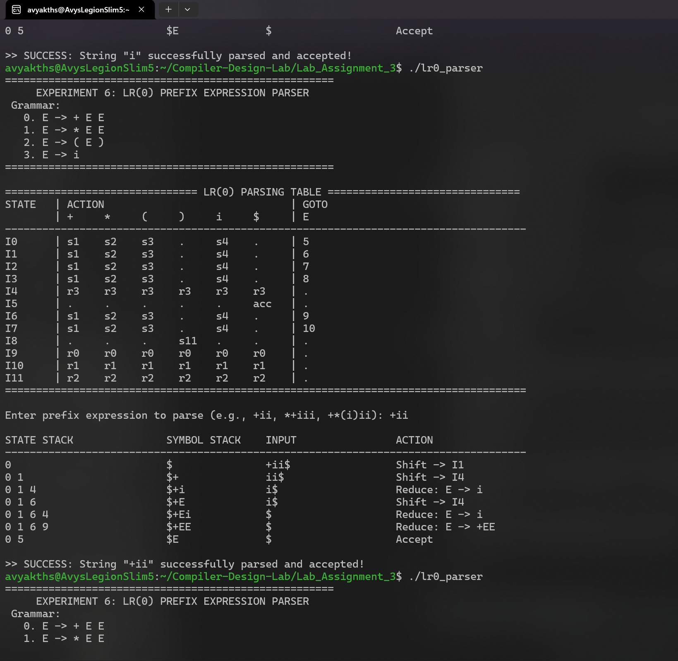
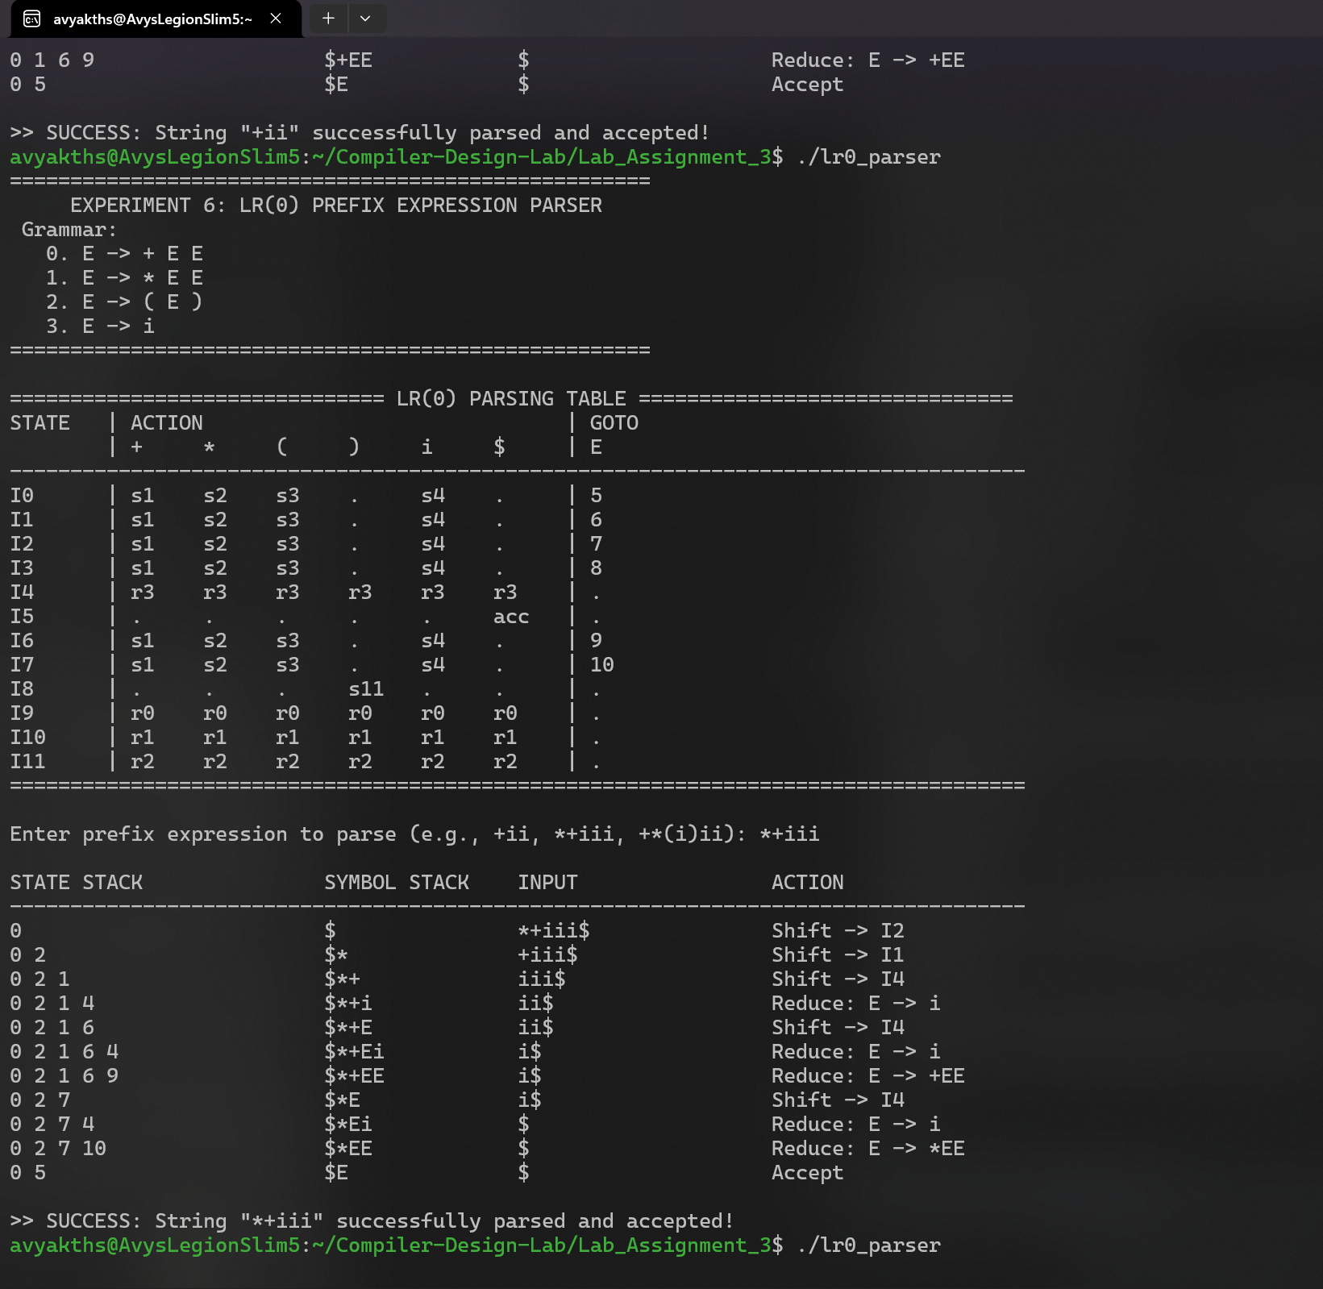
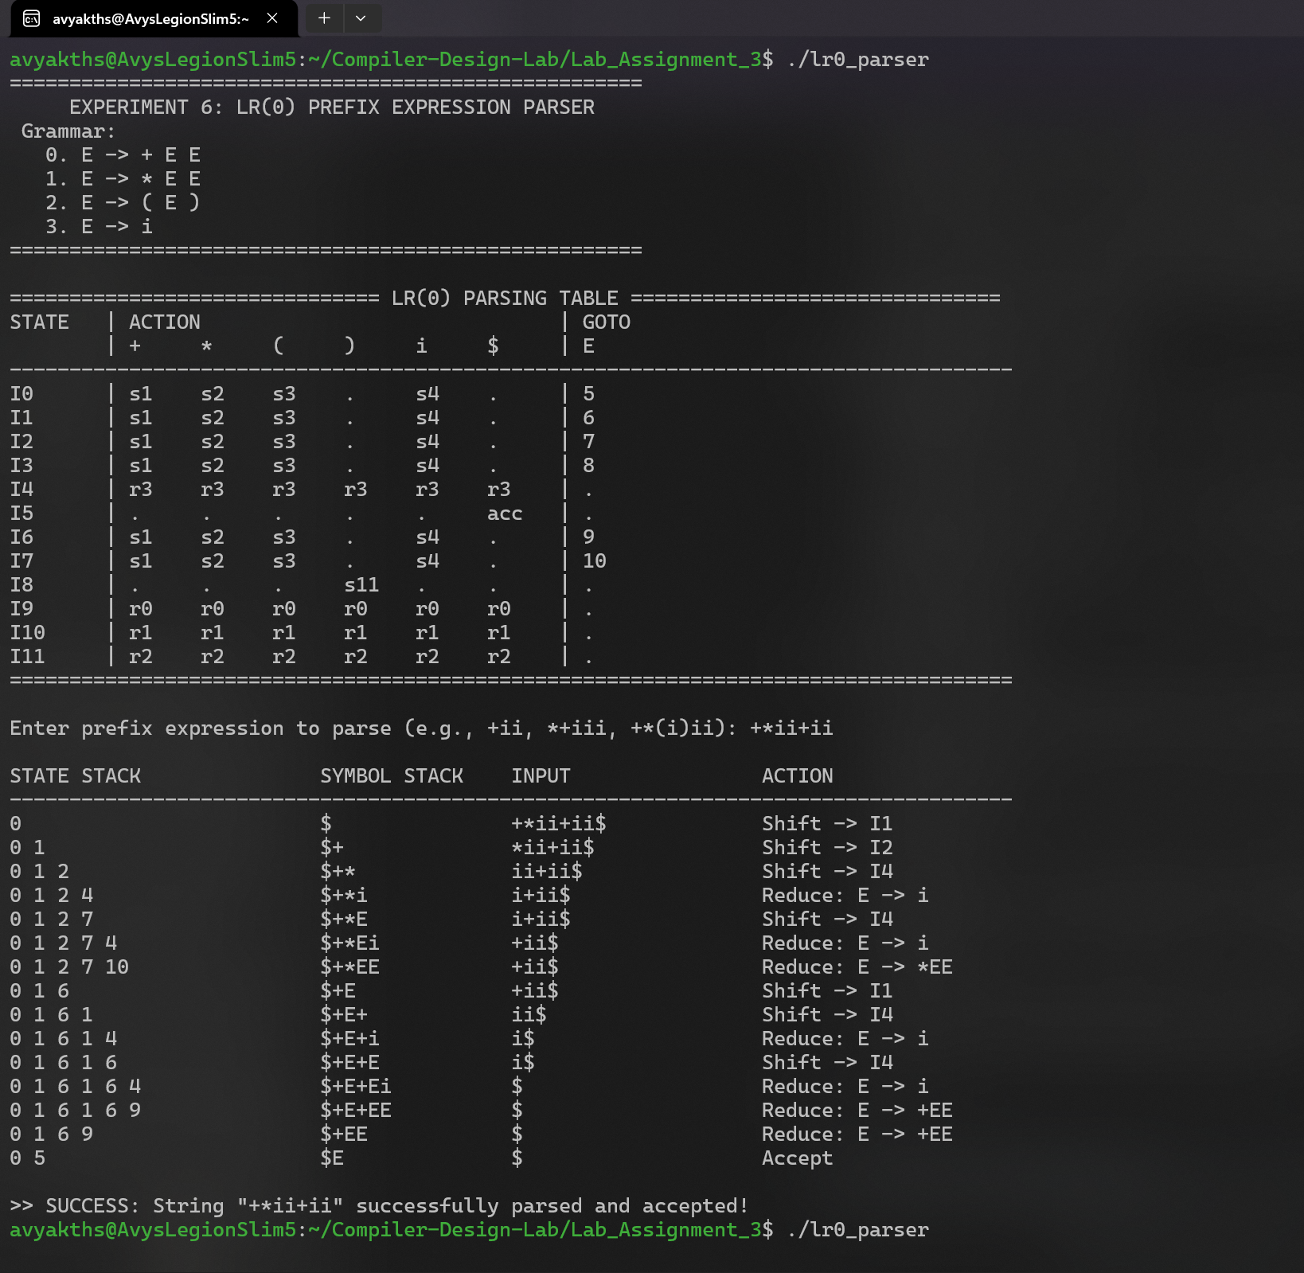
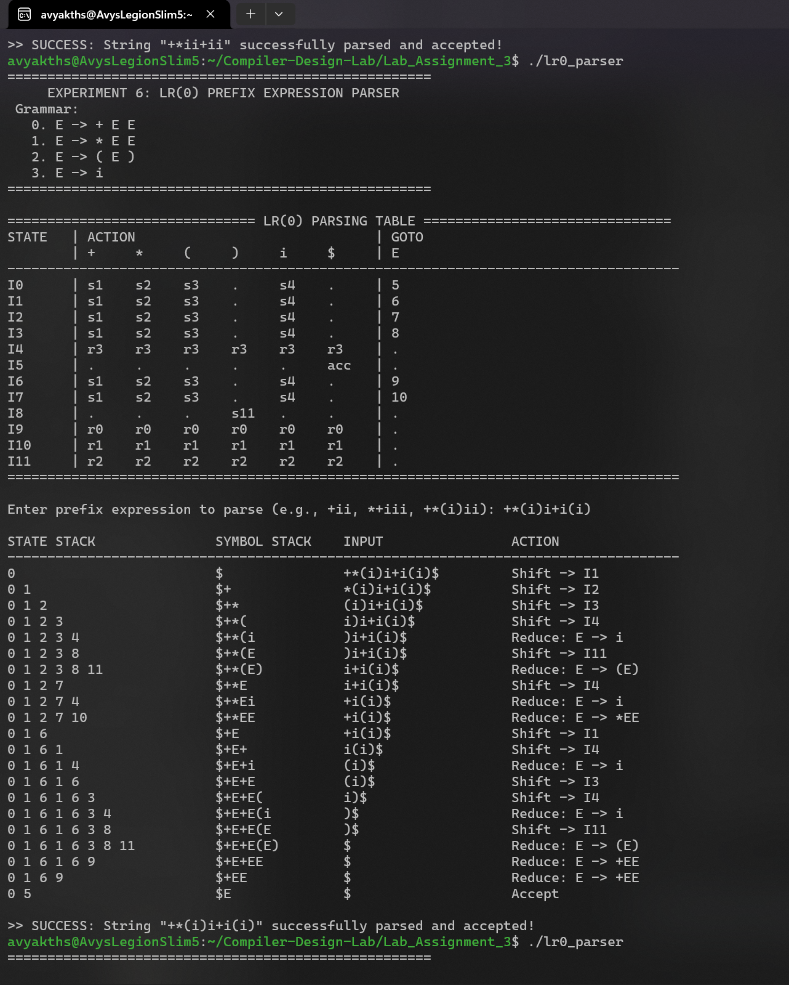
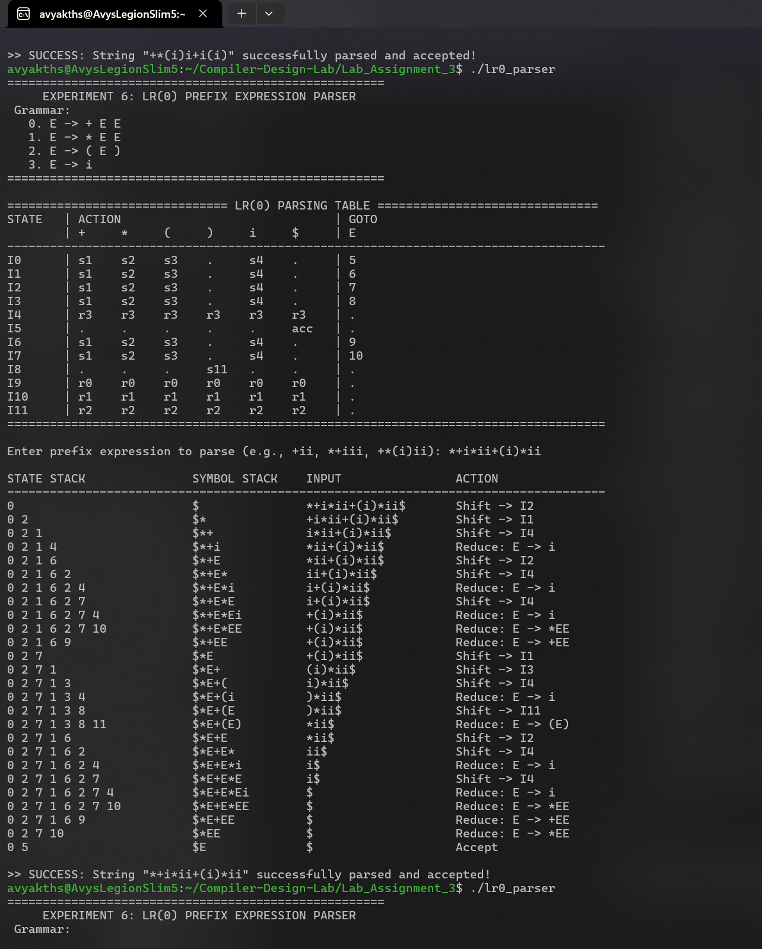
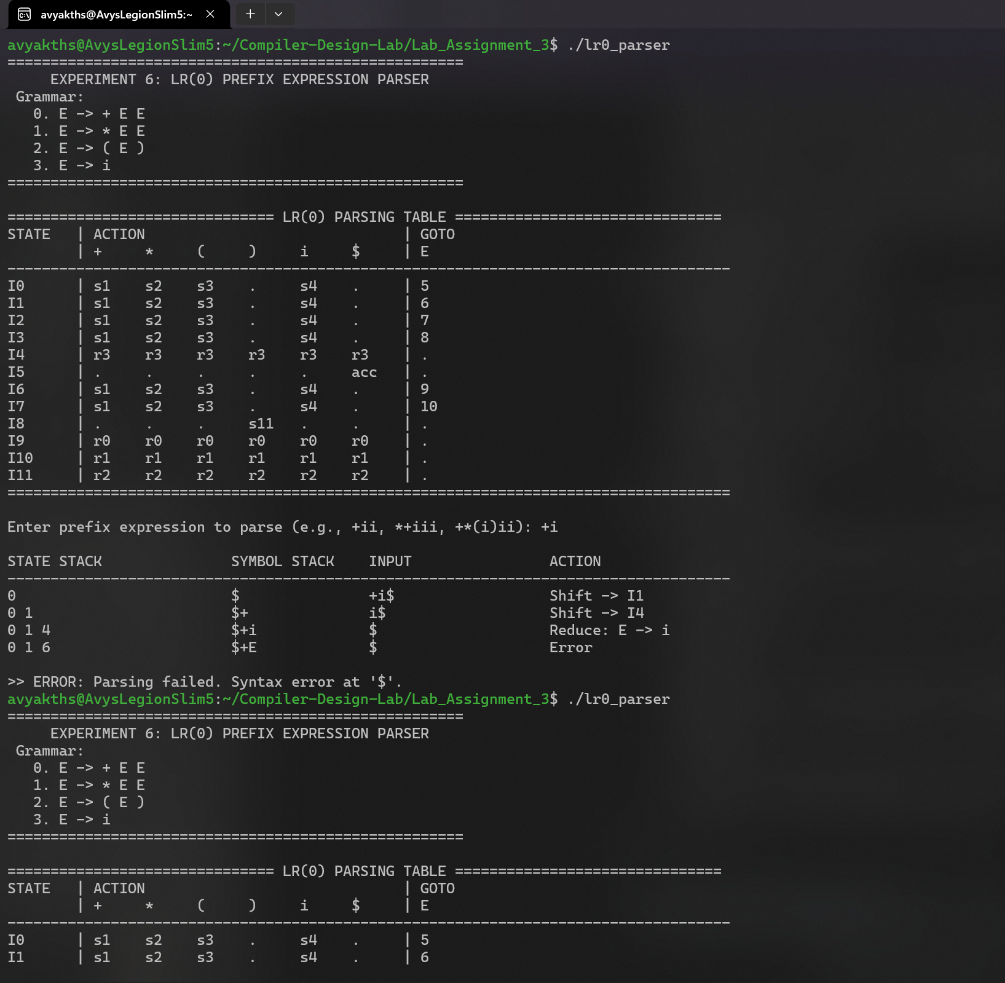
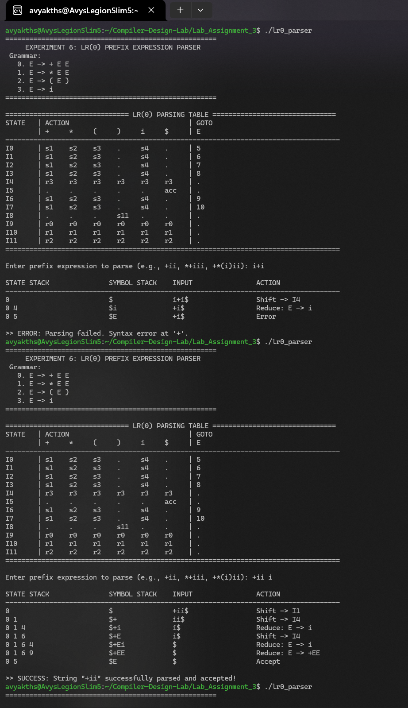
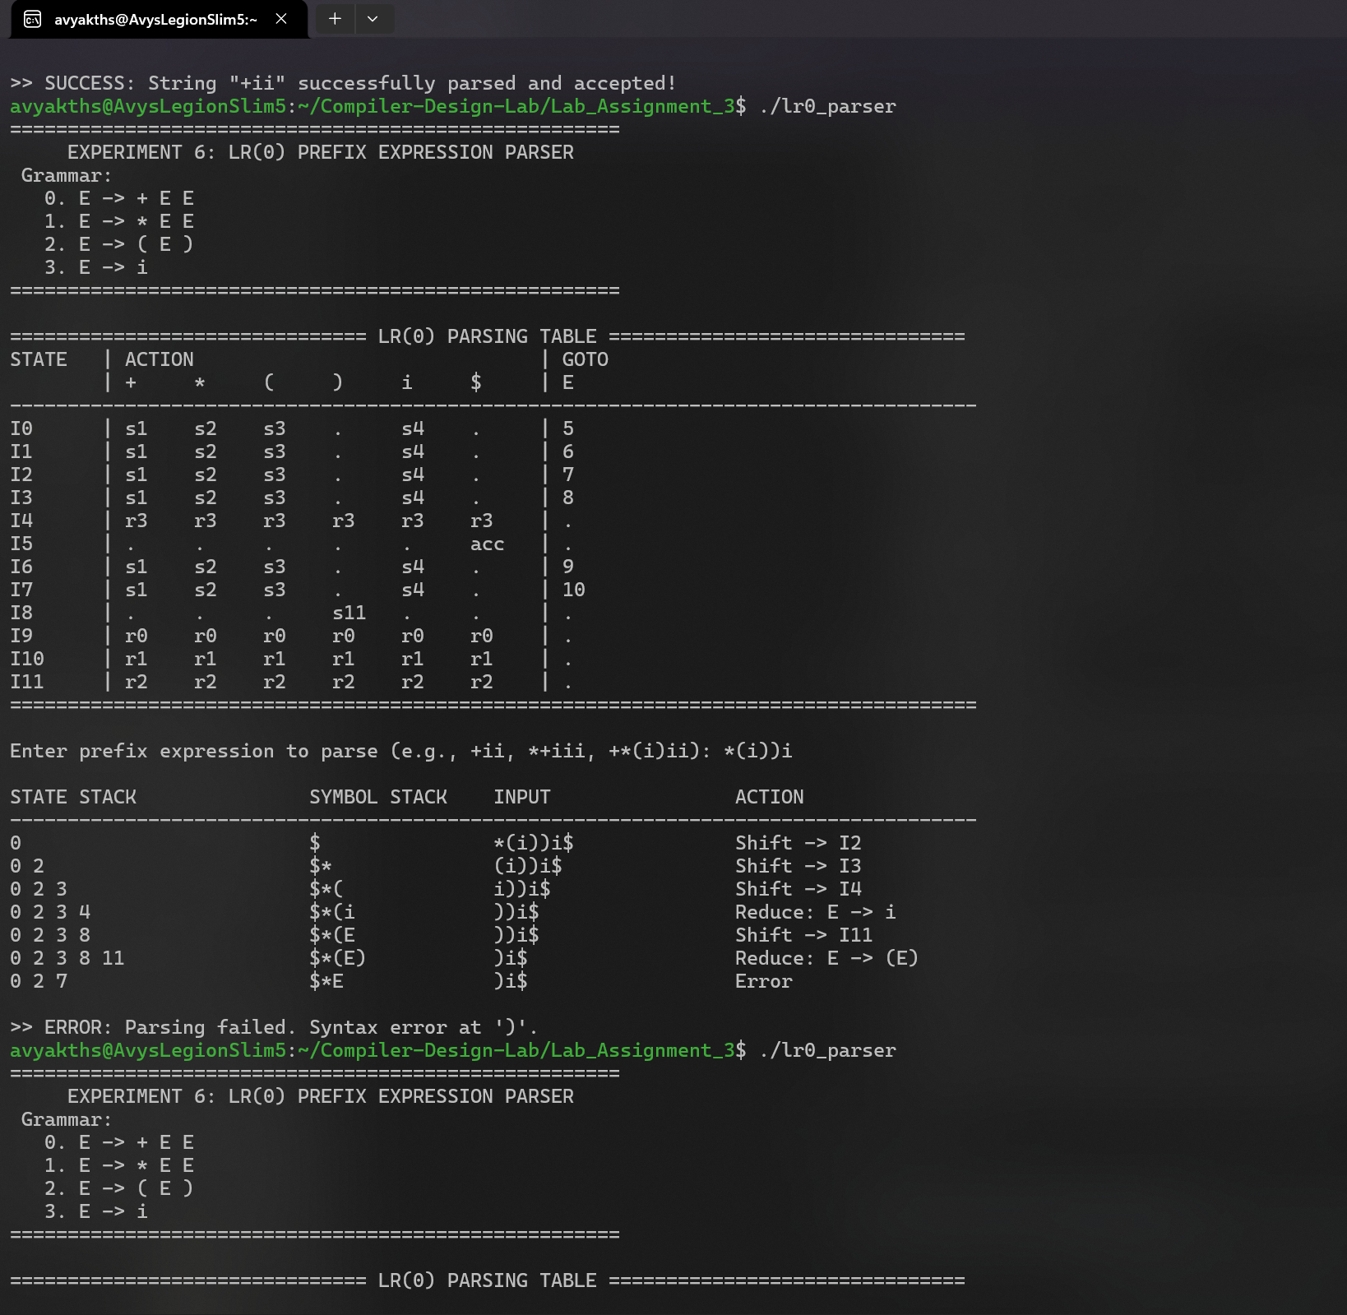
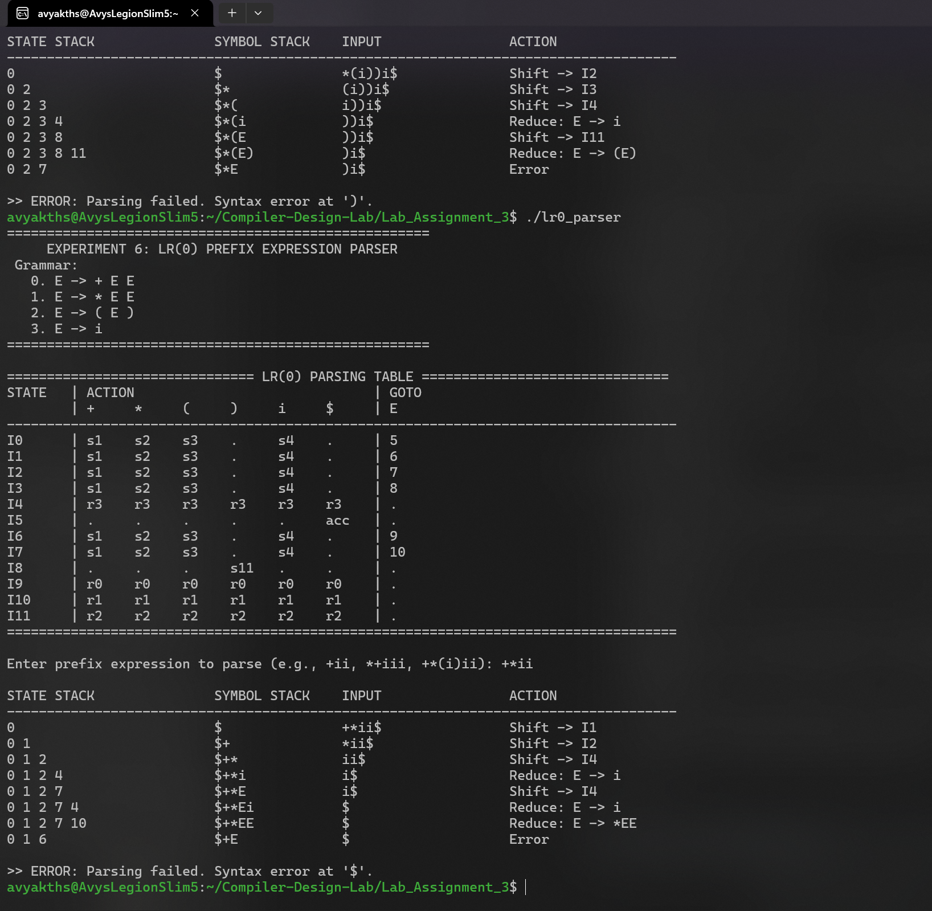

THANK YOU

